Address of Installation:
Invoice Date:
Invoice Number
Contact Person:
Place of Purchase
Contact Number:
Client Name:
1) Completed claim form 2) Proof of purchase 3) Electrical installation certificate
Please provide with your claim a copy of:
Wangara WA 6065
sales@premiumlighting.com.au
56153467040
Date:
Signature:
My signature below indicates I agree to the terms of this claim.
from the original. If a product is replaced or exchanged, the return becomes the property of Premium Lighting Pty Ltd.
Due to rapidly changing technology, Premium Lighting reserves the right to replace products with current models which may differ slightly in appearance
a fee if it is found that the installation does not adhere to the instructions supplied.
practice, product negligence or misuse. In the case of an electrical contractor issued out by Premium Lighting, Premium Lighting reserves the right to issue
Premium Lighting reserves the right to deny any claims where the product has not been installed by a licensed electrical contractor, incorrect installation
Description of Claim:
Product/s:
Contact Number:
Electrical License Number:
Electrical Contractor:
Warranty Claim Form
Email
ABN
Address
Phone
17 Niche Parade,
08 9248 1888
Premium Lighting Pty Ltd
and skill to ensure that its products are of reasonable
5.
All warranty claims are subject to manufacturer’s review
Practices Act 1974 (the “Act”) apply to contracts entered
and acceptance.
into by Premium Lighting for the provision of goods
b)
Any claim under the Warranty must sent in
6.
Premium Lighting warrants that it uses reasonable care
and services. In all other countries the local equivalent
writing to:
to which the provisions of the Commonwealth Trade
Trade Practices legislation shall apply and Premium
quality. Premium Lighting will at its cost and in its sole
Lighting exercises all of its rights to limit its liability to
Waranty Claims
discretion:
the full extent allowed. Pursuant to section 68A of the
Premium Lighting Pty Ltd
Act, this Clause 10 applies in respect of the goods or
by any applicable State or Territory law, liability is limited
excluded under the Australian Consumer Laws.
a) Our contact details for the purpose of any
allowed by law, Premium Lighting’s liability in respect
You are entitled to a replacement or a refund for a
claims made under the Warranty are:
of the product under the law of any State or Territory is
major failure and for compensation for any other
excluded. Where liability may be limited but not excluded
Premium Lighting Pty Ltd
reasonably foreseeable loss or damage. You are also
17 Niche Parade
17 Niche Parade
entitled to have the goods repaired if the goods fail to
to the full extent possible under that law.
Wangara WA 6065
be acceptable quality and the failure does not amount
08 9248 1888
to a major failure.
10. This Clause 9 will only apply in Australia to the extent
sales@premiumlighting.com.au
by Premium Lighting in its sole discretion:
address above by post or other agreed means.
Premium Lighting for assessment with a receipt or
Any such claim must be made within 14 days
other proof of payment.
(i) the replacement of the goods or the supply of
of your receiving notice of our acceptance of
equivalent goods;
7.
Premium Lighting has no liability to remedy any defect
or defect. All warranty claims must be returned to
your claim and include any necessary supporting
(ii) the repair of the goods;
in a product or replace a product where the defect or
documentation or invoices.
(iii) the payment of the cost of replacing the goods or
fault is caused or contributed to by
acquiring equivalent goods; or
(i) the failure of the Purchaser to install the product
(iv) the payment of the cost of having the goods repaired.
according to specific installation instructions supplied
we will reimburse all your reasonable expenses in
(i) remedy any defect or fault in any product
services supplied by Premium Lighting which are not
Wangara WA 6065
purchased; or
of the kind ordinarily acquired for personal, domestic,
(ii) replace any product in respect of which there is a
or household use or consumption, provided that this
c) If we accept your claim under the Warranty
defect or fault, during the warranty period, provided
Clause 10 will apply if the Purchaser establishes that
Except as provided for in this warranty, and to the extent
that written notice is given by the Purchaser to Premium
reliance on it would not be fair and reasonable. Liability
making and pursuing the claim, including the cost
Lighting of any such defect or fault in the product as
for a breach of a condition or warranty implied by the
of reimbursement of any defective Products
soon as the Purchaser becomes aware of that fault
Act is limited to any one of the following, as determined
returned in the ordinary course to us at the
Address
Premium Lighting Pty Ltd
08 9248 1888
17 Niche Parade,
Phone
ABN
Email
56153467040
sales@premiumlighting.com.au
Wangara WA 6065
Summary of Warranty
Premium Lighting will guarantee from the date of purchase against faulty workmanship or materials as stated below and subject to
the Terms and Conditions following:
2 Years
Warranty Information
Australian Consumer Laws
2.
5 Years Control Gear Warranty
3.
As a Consumer you have rights under the Australian
1.
Premium Lighting (“we” or “us”) has given each
within each product box or carton; or
Consumer Laws and may have rights under other
Purchaser who is a Consumer (“you”) a warranty
(ii) use of the product in a manner or for a purpose for
applicable laws which cannot be excluded, restricted or
against defects in its Products.
which it was not designed.
modified. Those rights are in addition to any rights you
Structural Warranty (Luminaire)
As a Consumer you should read the terms of the
8.
All site application or installation must reflect these
have under the Warranty.
Warranty which you are entitled to. For the purpose of
procedures otherwise the product warranty will be
4.
Our goods (which we refer to in the Warranty as the
the Australian laws, we note:
considered void or will not take effect.
Products) come with guarantees that cannot be
9.
Structural Warranty (Luminaire)
2 Years Control Gear Warranty
3 Years
Structural Warranty (Luminaire)
2 years Control Gear Warranty.
Structural Warranty (Luminaire)
3 Years Control Gear Warranty.
5 Years
7 Years
accordingly by consultants and lighting professionals
22. The use of high pressure water cleaners, corrosive
installations should be performed by a professional
of the products only and do not include any labour or
specifications at any time.
15. All items must be properly grounded and all
11. All claims are limited to the repair or the replacement
21. Premium Lighting reserves the right to alter fittings or
installation and after.
of the product is assumed by the Purchaser.
the failure of our products.
to extend and preserve public safety during the
charges. The entire risk as to the use and performance
to any ancillary equipment or inconvenience caused by
transportation charges. The entire risk as to the use
only and do not include any labour or transportation
20. Premium Lighting accepts no responsibility for damage
these parameters and selection must be exercised
limited to the repair or the replacement of the products
of registration. Product must therefore be used within
product or any claim by any other party. All claims are
lamp manufacturer’s warranty if any.
comply with rules and regulations in effect at the time
damages arising out of the use or inability to use the
19. There is no warranty offered on lamps other than the
governing safety bodies or public safety agencies to
lost savings or any other incidental or consequential
be respected throughout the product life.
damage driver electrical components and will void
required.
And will remain so throughout the life of the product.
regulatory authorities should be consulted where
installation matters will be the installer’s responsibility
the local, state and country electrical code. Appropriate
17. All installation matters and failures related to
13. All installations shall be performed in accordance with
product limitations.
or rejected.
warranty.
the primary intended use of a specific product or the
associated to this matter will be promptly dismissed
documented in the catalogue and/or listed by
verified with Premium Lighting directly if it deviates from
products. Any damage claim or product failure
23. High voltage insulation tests (megger) will permanently
representatives shall be reflected in the catalogue or
12. Power tools shall not be used to tighten or assemble
these types of cleaning methods may void warranty.
16. All information supplied by Premium Lighting’s
Purchaser.
function and/or appearance of luminaires. The use of
proper liability insurance.
and performance of the product is assumed by the
cleaning agents, and harsh abrasives, may damage the
electrician and or a duly licensed contractor carrying
Australian Consumer Laws
Warranty Information
Phone
Purchaser for any damages, including lost profits,
18. Lamp wattage and matching replacement parts must
14. Premium Lighting products have been factory tested,
In no event will Premium Lighting be liable to the
Wangara WA 6065
sales@premiumlighting.com.au
56153467040
Email
ABN
Address
17 Niche Parade,
08 9248 1888
Premium Lighting Pty Ltd

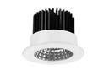
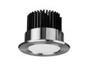

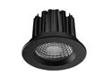
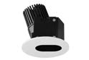
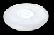
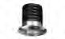
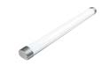
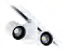
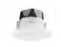
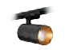

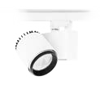
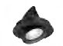
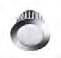
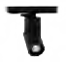
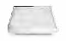
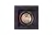
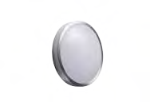
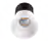
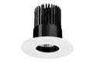
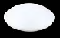
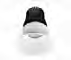
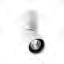
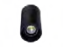
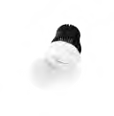
Kobalt Outdoor Light
3 Years
Platinum Commercial Series
7 Years
Apex Downlight Series
5 Years
Track Lights
Apex Adjustable Downlight
5 Years
3 Years
Space Ceiling Light
3 Years
Varano Slot Downlight
5 Years
Supalux Linear Light
Diamond Starlight
3 Years
Vega Outdoor Light
3 Years
Platinum Downlight Series
7 Years
Kobe Track Light Series
5 Years
Quartz Downlight
3 Years
Atom Track Light
5 Years
For more information about our warranty policy or to lodge
sales@premiumlighting.com.au
a warranty claim, visit premiumlighting.com.au/warranty
www.premiumlighting.com.au
Ruby Downlight Series
Product Name
Power
Axis Track Light Series
5 Years
5 Years
Horizon Track Light Series
5 Years
Ruby Cabinet Light
3 Years
Our range of luminaires are distinguished by class-leading quality and stunning design. We back
the design, build and manufacturing of each luminaire with an extended warranty. You can be rest
assured when choosing a Premium Lighting product that it will continue to perform for years to come.
Recessed Luminaires
Surface Mounted Luminaires
Product Name
Warranty
Product Name
Warranty
Warranty Information
Product List
Titanium Slotter Series
5 Years
Halo Ceiling Light
3 Years
Alpha Ceiling Light
3 Years
Luna Pin Spot Downlight
5 Years
Titanium Asymmetrical Downlight
Axis Surface Mounted Downlight
5 Years
Titanium Downlight Series
7 Years
Titanium Surface Mounted Downlight
7 Years
7 Years
Apollo Ceiling Light
3 Years
Titanium Starlight
3 Years
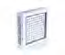
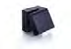
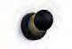

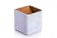
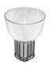
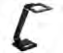
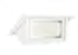
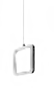
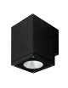
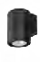
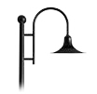
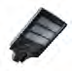
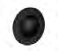
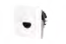
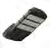

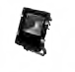

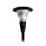
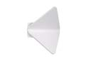
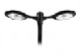
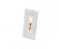
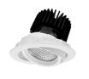
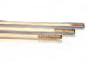
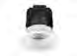
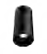

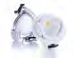
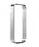
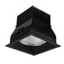
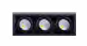
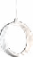
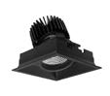
2 Years
Codex Reading Wall Light
5 Years
Diamond Canopy Light
2 Years
Zen Wall Light
5 Years
Diamond Panel Light Series
Tourmaline Wall Light
2 Years
5 Years
Diamond Highbay Series
2 Years
Athena Commercial Series
5 Years
Saturn Table Lamp
3 Years
Diamond Shopfitter
Product Name
Power
Diamond Flood Light
5 Years
Zeron Commercial Series
Indoor Wall
3 Years
Azure Step Light
5 Years
Aveta Street Light Series
Diamond Street Light Series
2 Years
www.premiumlighting.com.au
a warranty claim, visit premiumlighting.com.au/warranty
sales@premiumlighting.com.au
For more information about our warranty policy or to lodge
Ovo Step Light
2 Years
Topaz Step Light
5 Years
2 Years
Orbit Step Light
5 Years
Europa Street Light Series
3 Years
Sapphire Wall Light
5 Years
5 Years
Iberia Street Light Series
2 Years
Zenith Step Light
5 Years
Proteus Street Light Series
Warranty
Product Name
Warranty
Product Name
5 Years
Quantum Adjustable Downlight
5 Years
Titanium Pendant Light
3 Years
Eclipse Strip Light Series
5 Years
Quantum Downlight Series
Warranty Information
Feature
Commercial
Product List
2 Years
Beryl Table Lamp
3 Years
Arc Shopfitter
Parallax Downlight Series
5 Years
Atlas Pendant Light
3 Years
Unilux Pendant Light
Genesis Slotter Light Series
3 Years
Midas Pendant Light
5 Years
5 Years
Parallax Adjustable Downlight
3 Years
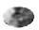
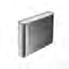

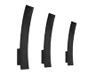
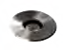
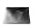
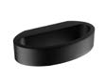
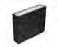
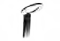
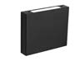

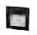
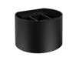
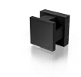
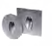
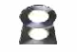
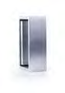
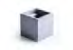
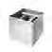
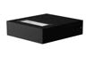
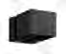
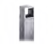
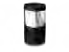
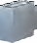
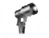
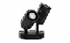

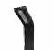
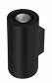
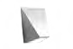
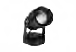
Madrid Wall Light
3 Years
Emerald Inground Uplight
3 Years
3 Years
Minq Wall Light
3 Years
Emerald Commercial Uplight
3 Years
Radius Pathway Light
Astro Wall Light
3 Years
Galaxy Bollard Light
3 Years
Astro Steplight
3 Years
3 Years
Nova Wall Light
3 Years
Emerald Deck Light
Cosmo Wall Light
3 Years
Zeus Wall Light
3 Years
Cuadro Step Light
3 Years
Sunstone Step Light
3 Years
For more information about our warranty policy or to lodge
sales@premiumlighting.com.au
a warranty claim, visit premiumlighting.com.au/warranty
www.premiumlighting.com.au
Altair Wall Light
3 Years
Bianco Wall Light
3 Years
Marc Wall Light
3 Years
Vespa Wall Light
3 Years
Outdoor Wall
Landscaping
Product Name
Warranty
Product Name
Warranty
Onyx Spotlight Series
3 Years
Warranty Information
Spectrum Spike Light
Product List
Asteria Wall Light
Castell Bollard Light
3 Years
3 Years
Moonstone Wall Light
3 Years
Concord Bollard Light
3 Years
3 Years
Onyx Wall Light
3 Years
Emerald Spike Spotlight
3 Years
Edge Wall Light
Emerald Spotlight
3 Years
3 Years

